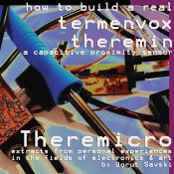
Teremini 4011 - capacitive proximity sensor and instrument
This kit is one of Trivia Records DIY projects and was prepared by
Borut Savski in collaboration with LJUDMILA Art and Science Laboratory.
The practice of DIY electronics is closely linked to our artistic projects - since our playground is media and technology.
Briefly, here is the list of components:
Resistors:  4x 22 KΩ  1x 27 KΩ  3x 270 KΩ | Capacitors:  2x 100 pF (little brown beads)  2x 10 nF (15nF may be in kit)  1x 100 nF  2x 10 uF electrolytic |   Potentiometer: 1x 10 KΩ linear  Diode: 1x 1N4001  Integrated circuits:  2x 4011 - quad 2-input NAND gate  made in EU with love  and poor man's SMD technology
THEREMICRO/ TEREMINI is the nickname for the simplest type of capacitive sensor, that in the past has been given the name "theremin" (originally "termenvox" - by its inventor Lev Nikolajevič Termen). The invention goes hand in hand with the pioneering years of radio - the electronic amplification - the 1920s. In fact, it is a cast-away of the development in the field of radio - namely: the heterodyne (frequency mixing) principle and the observation of the capacitive properties of human body. In termenvox this usually undesirable effects were put to good use.
The original "termenvox" was made using vacuum tube amplification elements, but here we use the simplest, readily available CMOS logic gates, that were introduced in the early 1970s. They do not provide the soft sound as termenvox used as an instrument, but do perform the proximity sensing function. The schematics was found in one of the journals for electronic engineers published in ex-Yugoslavia (originally published in a Russian journal) and then modified.
Termenvox is in essence a capacitive sensor that functions by comparing the frequencies of two oscillators. One of the oscillators is fixed and the other is coupled with the antenna to its surroundings. A human moving their hand acts as a capacitor to ground and adds themself to the oscillating system. The closer the hand (or any part of the body) - the higher the total capacitance and thus the lower the oscillating frequency. The free-running frequency (no hand near the antenna) of this variable oscillator should ideally be the same as that of the fixed frequency oscillator - making the difference of these two frequencies equal to zero.
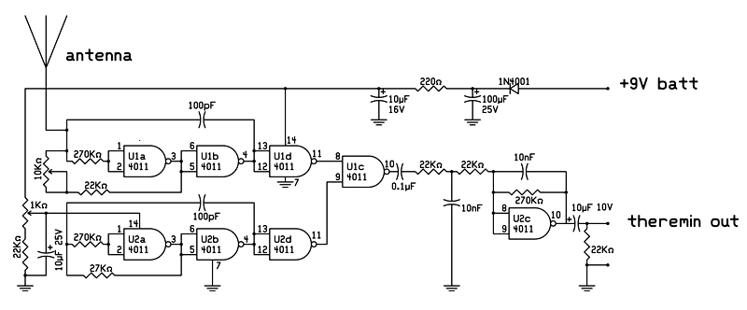
So: F_fixed - F_variable = F_audio
The frequencies are compared by mixing them together (intermodulation) and filtering out all the higher intermodulation results - leaving the basic difference of the two frequencies - which falls mainly into the audio spectrum (about 20Hz to 20KHz). In the ideal case the resulting tone with no hand near the antenna is silence.
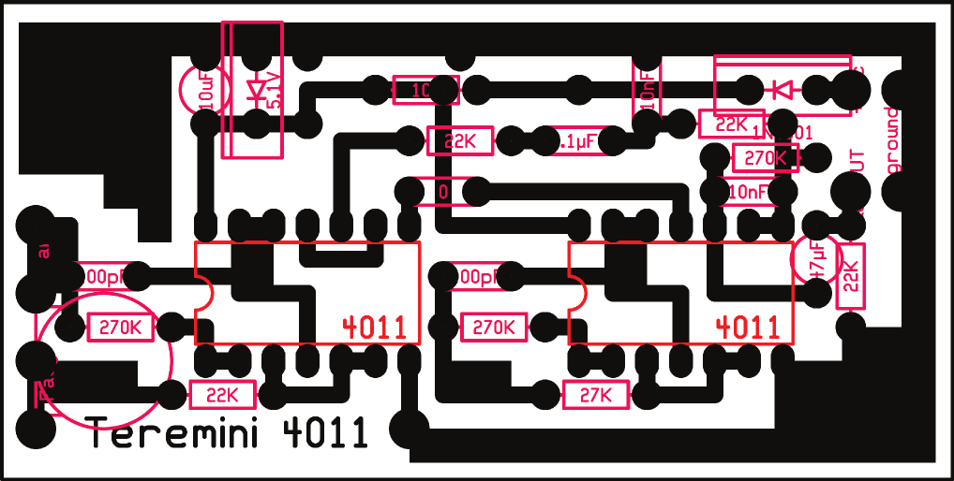

Borut Savski tells us about his experiences with the circuit:
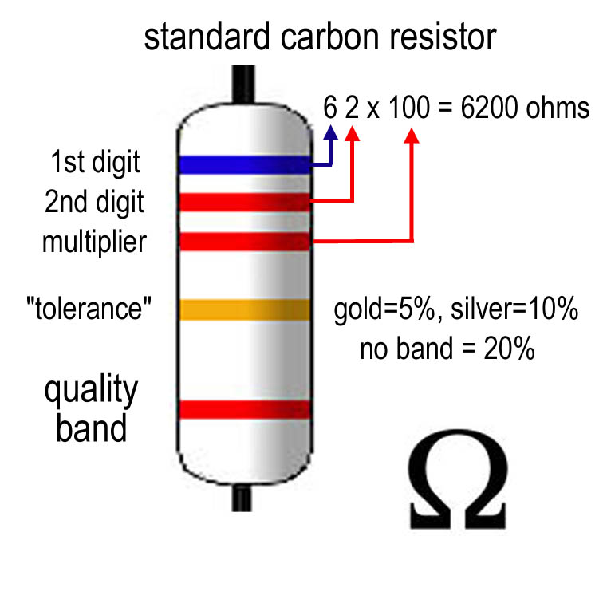Teremini is the smallest and simplest "termenvox" - a proximity detection electronic module. It was first used in an object (and project) called "The Round Table" - made for a concert at ÖRF 1 program Kunstradio, later in a more elaborate form for the project Singer by Marija Mojca Pungerčar, where they were attached to three sewing machines and produced their sounds while also mixing sound from three other sources.
I built a couple of these simple ones myself and others have built some more during the workshop of Cirkulacija 2 initiative at the Sajeta new music festival 2008. With the values shown they all performed well - so this is a kind of "production situation". A couple of similar circuits can be found around the net - they are all basically the same - built around CMOS NAND gates.
Various metal objects are used as antennas, requiring a wide tuning range. The basic drawback that lowered the effective sensitivity of the "hand", was always the closeness of wall or floor. During the testing with different wire forms the best one proved to be a "snake" design which i believe has something to do with "yagi" antenna design. Anyone can try to check out the necessary distances (the wavelength) between the "snake's" undulations and the length (the amplitudes) of it...
The output is an audio frequency which is very sharp and "dirty" because of odd harmonics that make up a "square" wave. And this is the main problem in using digital circuits. One can try to filter the higher harmonics out - but because of the wide frequency range - a couple of octaves - this would be quite impossible.
Still it was used for some noise music concerts by some people and myself in the last couple of years. I also used it a couple of times as controlling input to computer (and to software like Ableton Live or Pure data) and this I see as the right way to go - to use the theremin as interface...

LJUDMILA says:
We are very pleased that Borut taught us how to make Tereminis on workshops at our laboratory and excited that the participants started playing together as the Theremidi orchestra.
We now also have everything necessary to etch the circuit boards, so we can make more anytime we want!


